Software Detailed Design Specification
1.0

Table of Contents

1 Coverage Justification 2

References

Definitions

Term | Abbreviation | Description
ms | Milli second | Time unit

Revision History

Version | Date | Author | Description of changes
1.0 | Nov-19-2024 | vrk | This document is the Coverage Justification in Ctrl_warning

Coverage Justification

- Update Master lamp status is not covered as no warnings has associated lamps.
- Drop in UpdateWarningStatus
There are only 3 Possible values of Warning Event.
None – 0
Forced -1
Retrigger -2

There is a separate logic for check of NONE and other logic is to check for != FORCED and != RETRIGGER. The FALSE case could not be covered because giving FORCED/RETRIGGER will cover the other condition and giving NONE will satisfy the 1st condition.

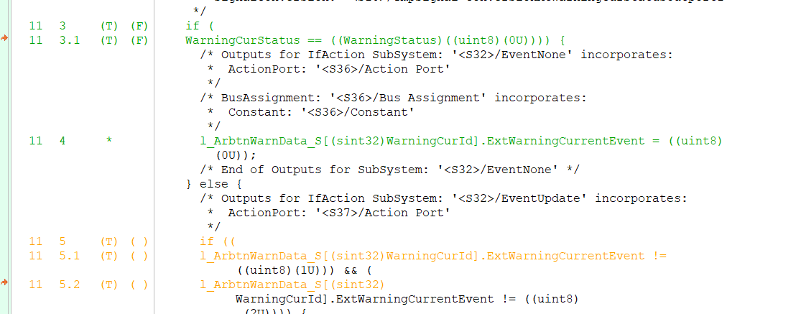

Hence this coverage drop can be deviated.

